What Is Suit Filed and How to Remove It in CIBIL Report?
[Edit to existing copy: H1 capitalisation corrected to APA ("How To Remove it" became "How to Remove It").]
Imagine applying for a personal loan and spotting "Suit Filed" next to your name in your credit report. Confused? You're not alone.
Many borrowers discover this tag only after their loan application gets rejected or delayed. It means a bank or NBFC has taken legal action over unpaid dues or a loan default.
The good news? This status isn't permanent. You can fix it.
This guide covers what Suit Filed means and how to get it off your CIBIL report, step by step.
[Edit to existing copy: "In this guide, we'll break down" is a signposting marker; reworded.]

Alt text: Hero FinCorp banner: a man studying a credit report marked Suit Filed on a laptop, with the line Understand. Act. Clear Your Credit Report.
Image Source
To Avail Personal Loan Apply Now

What Does a Suit Filed Mean in CIBIL?
In simple terms, "Suit Filed" means your bank or NBFC has started legal action to recover unpaid dues and officially reported it to TransUnion CIBIL (Credit Information Bureau India Limited). It's a red flag for future lenders as it shows a serious repayment issue in your past.
Let's say you missed several EMIs on a personal loan and didn't respond to reminders. The lender may report the account as "Suit Filed," along with the date and outstanding amount. This entry stays visible in your credit report until it's cleared, which can affect your future borrowing ability.
Remember, "Suit Filed" doesn't always mean a court judgment has been passed. It can also show up when your lender includes the account in its mandatory recovery filings under RBI norms.
Also Read: How to Unlink UPI from Your Bank Account

Why Is Suit Filed Status Critical in Your CIBIL Report?
The Suit Filed status in your CIBIL report is a serious remark that can damage your creditworthiness and sharply lower your credit score. Here's how:
- Loan rejections: Most banks and NBFCs treat this as a high-risk indicator and decline fresh applications.
- Reputation risk: A Suit Filed status typically coincides with overdue payments and defaults that pull down your rating.
- Limited negotiation power: Lenders may offer higher interest rates or lower amounts if you have this remark.
- Long-term impact: The record can remain visible for years, even after you clear dues, unless officially updated or disputed.
That's why understanding the meaning of a Suit Filed in CIBIL and resolving it quickly matters for your financial recovery.
Also Read: What is Written Off in CIBIL?
[New section: How Does a CIBIL Suit Filed Impact Your Credit Score? Brief: practical impact explainer, list format, about 70 words, keyword "cibil suit filed", reference SMFG India Credit.]

How Does a CIBIL Suit Filed Impact Your Credit Score?
A CIBIL suit filed remark hurts in two ways, and the second is the one people miss.
- Months of missed payments sit behind it, and they've already dragged the score down, usually well under the 700 most lenders want.
- Because the flag sits in the account status, a lender's policy filter can decline you before anyone looks at the score.
- Any credit that does come is priced for the risk, so higher rates and lower limits.
- And it stays until the lender updates it, however long you wait.
[New section: Types of Suit Filed Status in a CIBIL Report. Brief: informational, about 100 words, keyword "suit filed wilful default written off", reference SMFG India Credit.]

Types of Suit Filed Status in a CIBIL Report
Each account's 'Suit Filed / Wilful Default' field carries one of four values. Written off and settled sit in a separate field and can appear alongside, which is why suit filed, wilful default and written off turn up together on one report and mean three different things.
Status | What it means
No Suit Filed | The default value. No legal action has been reported.
Suit Filed | The lender has filed a recovery case, in a civil court, a Lok Adalat, or a Debt Recovery Tribunal for dues of Rs 20 lakh and above.
Wilful Default | The lender holds that you could pay and didn't, or diverted the funds. Under RBI's 2024 directions the tag needs a committee process and a chance to respond, and applies to dues of Rs 25 lakh and above.
Suit Filed (Wilful Default) | Both at once: a case in court and a wilful default classification. The hardest to shift.

How to Check if There Is a Suit Filed Against You in CIBIL
Wondering if you have a Suit Filed in CIBIL? You can check it yourself in minutes, no bank visits needed. Here's how:
Step 1: Go to www.cibil.com and sign in with your details. If you're new, create a quick account.
Step 2: Download your latest credit report. You'll find it under "My Account" or "Credit Reports."
Step 3: In the "Account Information" section, open each loan or credit-card entry to see what's written under "Status".
Step 4: Look for remarks like "Suit Filed," "Wilful Default," or "Written Off."
Pro Tip: Save a copy of your report. It'll come in handy later for tracking updates or fixing errors.
Also Read: Negotiating a Personal Loan Settlement: Everything You Need to Know

Step-by-Step Process to Remove Suit Filed From Your CIBIL Report
If you find a Suit Filed tag on your report, do not panic. Follow this structured approach to get it removed:
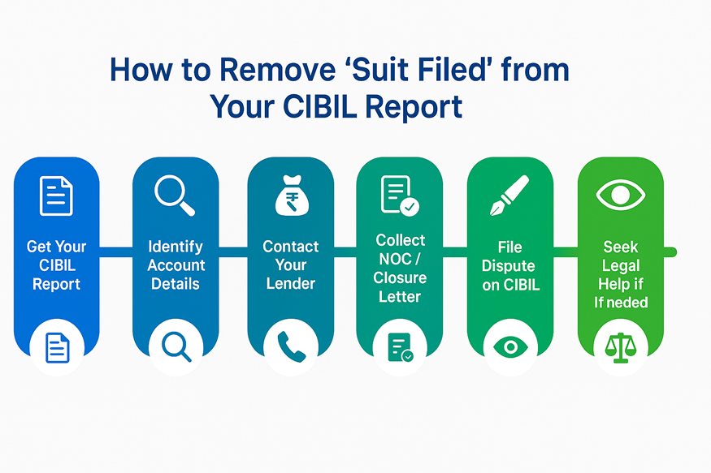
Alt text: Infographic: six steps to remove Suit Filed from your CIBIL report, from getting the report to seeking legal help
Image Source

1. Get Your Latest CIBIL Report
Start by downloading the most recent version so you have accurate information before taking any action.

2. Identify the Account and Details
Write down the lender's name, filing date and total amount to reach the right branch later.

3. Speak to Your Lender
Contact your lender's customer service or recovery department and ask:
- Why was your account marked "Suit Filed"?
- Whether the case is active or closed.
- The exact balance due, including any penalties or interest.

4. Clear or Settle Your Dues
Once you know how much you owe, either repay it in full or discuss a practical settlement with your lender. Get written proof of the final amount and terms.

5. Get No Dues Certificate (NOC) or Closure Letter
After full payment or settlement, ask your lender to issue a No Dues Certificate or Loan Closure Letter. It's the evidence CIBIL needs to update your record.
[Edit to existing copy: "It's crucial evidence" reworded; "crucial" is a detector marker.]

6. File a Dispute With CIBIL to Remove the Suit Filed Entry
Go to the CIBIL Dispute Resolution Portal and:
- Select "Dispute an Item" under "Credit Report Help."
- Attach your NOC or closure proof.
- Explain that the loan is now settled or closed.

7. Keep an Eye on the Progress
Check your CIBIL account every few weeks. If nothing changes after 30 days, follow up with both your lender and CIBIL's customer care.
[Edit to existing copy: "after 45 days" changed to 30 days. RBI's October 2023 circular gives the lender 21 days and CIBIL 9 days, 30 in total, after which Rs 100 a day compensation applies.]

8. Get Legal Advice if Challenges Persist
If updates are delayed or seem wrong, talk to a credit lawyer or finance professional for guidance.
Also Read: Who Is a Wilful Defaulter? RBI Rules Explained

How to Dispute a Wrongly Filed Suit on Your CIBIL Report
Sometimes the remark is a mistake. Data entry errors and outdated records happen. In such cases, follow this process:
Step | Action | Documents Required
1 | Log in to your CIBIL account | PAN, registered email ID
2 | Select "Raise a Dispute" | Credit report with marked entry
3 | Choose "Incorrect Suit Filed Status" | Identity proof, PAN, and communication proof from the lender
4 | Upload evidence that the account is active or cleared | NOC, bank statements, settlement letter
5 | Submit and track a dispute | CIBIL will confirm with the lender before making changes

If verified, CIBIL will delete or modify the "Suit Filed" status and send an updated report to you via email.
[New section: Difference Between Suit Filed, Written-off, and Settled Status. Brief: comparative clarifier, about 150 words, keywords "suit filed", "settled status", "written off", reference SMFG India Credit.]

Difference Between Suit Filed, Written-off, and Settled Status
These three remarks describe different stages of the same bad debt, and lenders read them differently.
Status | What happened | Is the debt still owed? | How lenders read it
Suit Filed | Legal recovery action has begun | Yes, plus legal costs | An active default. Usually an automatic decline.
Written-off | The lender has written the dues off in its books, typically after 180 days or more of non-payment | Yes. The lender can still recover it. | A serious default. Some lenders will consider you once it's paid.
Settled | You paid an agreed amount lower than the full dues and the account was closed | No | Negative, but the softest of the three. The score recovers as newer accounts stay clean.

Order matters here. Suit filed accounts can later show written-off, and a written-off account can end as 'Post (WO) Settled' once you pay part of what was owed. Only full payment gets you to the clean end state, which is 'Closed' with a zero balance and no remarks. Settled clears the debt but leaves the record.

Consequences of Not Removing Suit Filed Status From CIBIL
Leaving a Suit Filed tag untouched can quietly stall your financial comeback. Here's what can happen if you ignore it:
- Your score heals more slowly. Recovery takes longer, even with timely payments.
- Lenders stay cautious. The tag makes you look like a high-risk borrower on paper.
- Loans get costlier. Expect higher interest rates or smaller approved amounts.
- Credit cards freeze up. New or premium card offers often pause until the tag is gone.
- Opportunities slip away. One unresolved tag can hold you back from big goals like a home loan or emergency credit.
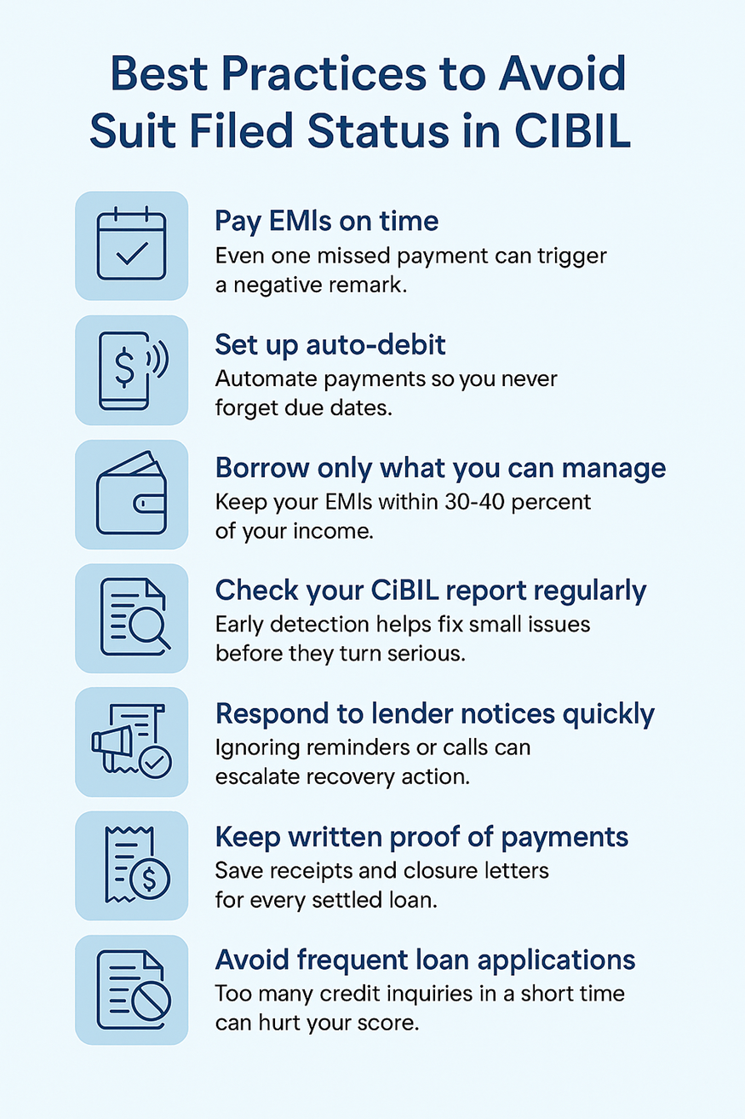
Alt text: Infographic: best practices to avoid Suit Filed status in CIBIL, from paying EMIs on time to avoiding frequent loan applications
Image Source

Your Credit Comeback Starts With the Right Action
A Suit Filed remark doesn't mean your financial journey is over. It's simply a signal to act quickly and responsibly. By clearing dues, obtaining NOCs and filing disputes on time, you can restore your credit health and rebuild trust with lenders.
Turn your financial comeback into reality. Get instant personal loan approval online with Hero FinCorp.
[New section: Conclusion. Brief: wrap-up plus soft CTA, about 60 words, keyword "cibil suit filed".]

Conclusion
A CIBIL suit filed remark isn't a verdict, but it won't leave on its own. Pull the report, find the account, clear or settle it, collect the closure letter and raise the dispute, then check the report again in 30 days. That sequence takes a month or two if the lender cooperates, and it is the only thing that gets the flag off; every loan you apply for in the meantime is priced against it.

Frequently Asked Questions
[Editor note: Existing FAQs 1 and 3 are folded into the new FAQs below, which ask the same questions in the brief's wording; existing FAQ 2 stays.]
[New section: six new FAQs from the brief.]

What Is a Suit Filed in CIBIL?
It's an account status showing your lender has started legal proceedings to recover overdue dues, reported to TransUnion CIBIL along with the date and the amount. There may be no ruling yet; the entry only says a case exists.

Does a Suit Filed Status Reduce CIBIL Score?
Yes, though indirectly. CIBIL doesn't deduct a fixed number of points for the remark itself; the score falls because of the months of non-payment that led to it, and it stays low while the balance sits unpaid. Then the flag does separate damage. Many lenders decline any report carrying it, whatever the score says. So the account has to be fixed before the score can be.

Can the Suit Filed Status Be Removed Instantly From CIBIL?
No. CIBIL needs confirmation from your lender before making corrections. The process typically takes up to one month.
[New section: remaining new FAQs.]

What's the Difference Between Suit Filed and Written-off?
Suit filed means the lender is still chasing the money through the courts. Written-off means it has stopped expecting to recover it in its accounts, usually after 180 days of non-payment. One account can carry both, and both stay until you clear the dues.

Can I Get a Loan While a Suit Filed Entry Is Active?
It's rare, and the terms are poor when it happens. Most lenders' policies treat the remark as an automatic decline; the few that lend price for it, and price hard. Clear the dues and get the entry updated first; approvals and rates improve within one or two reporting cycles.

What Documents Do I Need to Raise a Dispute for Removal?
Your CIBIL report with the entry marked, the No Dues Certificate or loan closure letter from the lender, proof of the final payment or the settlement letter, and your PAN. If the lender filed the suit in error, add the written communication that says so. CIBIL confirms with the lender before changing anything.

How to Clear a Suit Filed in CIBIL?
Pay or settle the account with the lender, take a No Dues Certificate, then raise a dispute on cibil.com under Credit Report Help and attach the certificate. Your lender has 21 days to confirm and CIBIL nine more to update. Past 30 days, RBI's compensation rule pays you Rs 100 a day for the delay.

